**Hardware Requirements:**

A lot of different hardware’s were used in this project. Details of the hardware are given below.

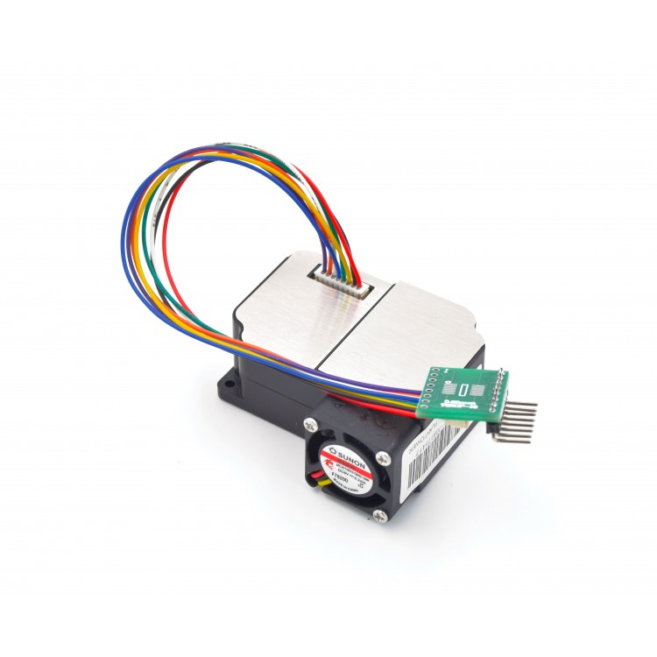

Track in real-time PM2.5 dust concentrations. It’s super easy to set up and start using right out of the box with our example Arduino code, along with pre-soldered headers and pre-connected wires. This high precision dust sensor can also be used to measure PM10 **in addition** to PM1.0. PM1.0 isn’t the concentration standard commonly used by governments or agencies, but it’s just as, if not more important than PM2.5+. We can get a reliable reading of dust concentrations between 0.3 to 10um using a light scattering analysis method. This method determines particle motion and density by measuring fluctuations in the intensity of scattered light. The microprocessor then calculates equivalent particle diameter and the number of particles with different diameter per unit volume. This technique enables users to measure very small particles, particles that fall below even 1.0um in size.

It’s a nifty little module that will help you create an accurate air quality or weather-related project.What’s included: The sensor box with pre-attached cables, and a breakout board with pre-soldered 90-degree male headers

**Features**

* Measure PM1.0 pollutant levels or below, down to 0.3um
* Accurate and stable data output
* Serial output
* Onboard fan
* Can connect it directly to a PC with a USB cable

**Specifications**

* measurable dust diameter: 0.3-1.0 um, 1.0-2.5um, 2.5-10um
* Data unit: ug/m3
* Resolution: 0.3ug/m3
* Range: 0-999ug/m3
* Response Time: less than 10s
* Operating Voltage and Current:  5V, 200mA,
* Sleep Model Current: 2mA
* Port: 3.3V TTL
* Module Dimension: 50.2x45.0x20.8mm

**Pin Definition**

|  |  |
| --- | --- |
| Pin1 | VCC (5.0V) |
| Pin2 | GND |
| Pin3 | SET |
| Pin4 | RXD |
| Pin5 | TXD |
| Pin6 | RESET |
| Pin7 and Pin8 | NC |

**Arduino Uno R3**

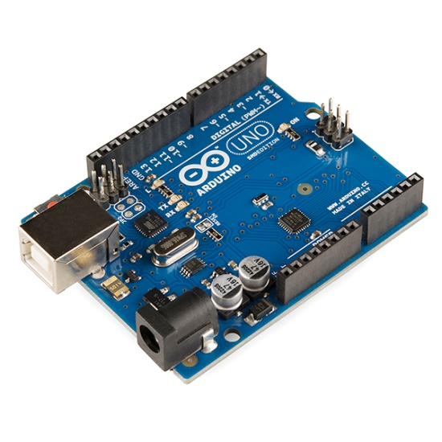

It is an open source microcontroller platform board used for building electronic projects, it is made using ATmega328p microcontroller, an 8-bit microcontroller with 32KB of Flash memory and 2KB of RAM. We simply connect the Arduino with a USB cable to the computer to get it started or use a battery.

**Advantages:**

* Really open source software and hardware
* Easy to learn
* Huge community
* Low cost boards and peripherals

**Disadvantages:**

* It's mostly still AVR (8-bit) "eco-system" (and +5 V). There is many claims that other (e.g. ARM) architecture are supported but you'll find pretty soon that even 32-bit boards designed by Arduino team (e.g. Due, Zero, MKR) are not supported in a similar way to 8-bit (Uno, Leonardo, Mega2560): they are still second choice
* If we need more processing power and working memory, we will have to move on to other implementation.

**DJI 2212 920KV Brushless Motor for Drone**

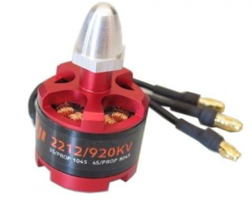

920Kv Brushless DC Motor is a Brushless DC electric motor (BLDC motors, BL motors) also known as electronically commutated motors (ECMs, EC motors) are synchronous motors that are powered by a DC electric source via an integrated inverter switching power supply, which produces an AC electric signal to drive the motor.

**Features of DJI 2212 920KV Brushless Motor:**

* KV(rpm/v): 920.
* Max Power: 370W.
* Max Thrust: 1200 grams.
* Weight: 53 grams.
* Shaft Diameter: 4mm.
* Shaft Length: 49mm Recommended Propeller for battery: 12x4.5 for 2S battery; 10x4.5 for 4S battery.
* Battery: 2S-3S Li-Po.
* ESC (A): FMT 30A (recommended).

**Applications of DJI 2212 920KV Brushless Motor:**

* Used in light weight quadcopters.

**DJI F450 Frame**

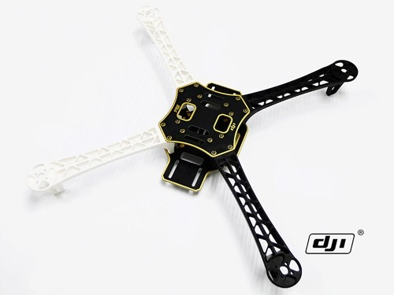

DJI F450 Flame Wheel QuadCopter frame is designed for all pilots for fun or with the use of an autopilot.

The Flame Wheel F450 Quad can be used with either the [DJI Wookong M Multi Rotor Controller](https://www.buildyourowndrone.co.uk/dji-wookong-m-multi-rotor-controller) or [Naza M V2](https://www.buildyourowndrone.co.uk/dji-naza-m-v2-gps-flight-controller) autopilot systems to achieve hovering, cruising, even rolling and other flight elements. It can be used for entertainment, aerial photography, FPV and other aero modelling activities.

The DJI F450 Flame Wheel frames are built from very strong materials, the arms are made from the ultra strong PA66+30GF material which provides better resistance to damage on hard landings, while the main frame plates use a high strength compound PCB material, which makes wiring of ESCs and battery easy and safe on the lower of the two frame plates which is also the power distribution board. The overall frame design provides enough space when assembled to fit an autopilot systems between the top and bottom plates of the Flame Wheel. The arms supplied in the kit are different colours, 2 red and 2 white to allow for improved visual orientation in flight, other coloured arms in black are available.

These frames are very easy to build and are held together by a set of shouldered bolts, the bolts pass through the predrilled holes in the top and bottom frame plates of the F450 Flame Wheel into the top and bottom of the arms, a total of 6 bolts per arm holds the frame plates in place and ensures that the F450 Flame Wheel frame is very solid, and are able to put up with a great deal of use or abuse!

|  |  |
| --- | --- |
| **Frame** | F450 Flame Wheel |
| Diagonal Wheelbase | 450mm |
| Frame Weight | 282g |
| Takeoff Weight | 800g ~1600g |

**Ardupilot APM 2.8 Flight Control Board Bend Pin with Protective Case**

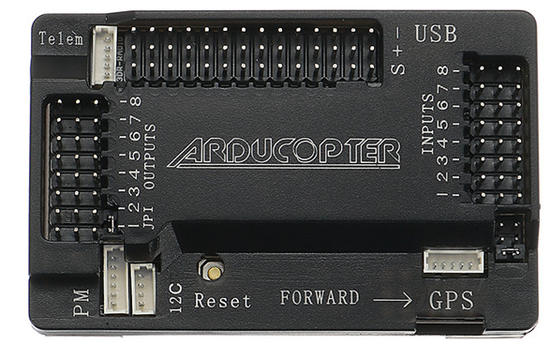

**Specification:**  
Item Name: APM 2.8 Flight Control Board

**Features:**

Compatible!

Includes 3-axis gyro, accelerometer, along with a high-performance barometer

Onboard 4 MegaByte Dataflash chip for automatic datalogging

Optional off-board GPS, LEA-6H module with Compass.

One of the first open source autopilot systems to use Invensense's 6 DoF Accelerometer/Gyro MPU-6000.

Barometric pressure sensor upgraded to MS5611-01BA03, from Measurement Specialties.

Atmel's ATMEGA2560 and ATMEGA32U-2 chips for processing and usb functions respectively.

**GPS- Neo-7**

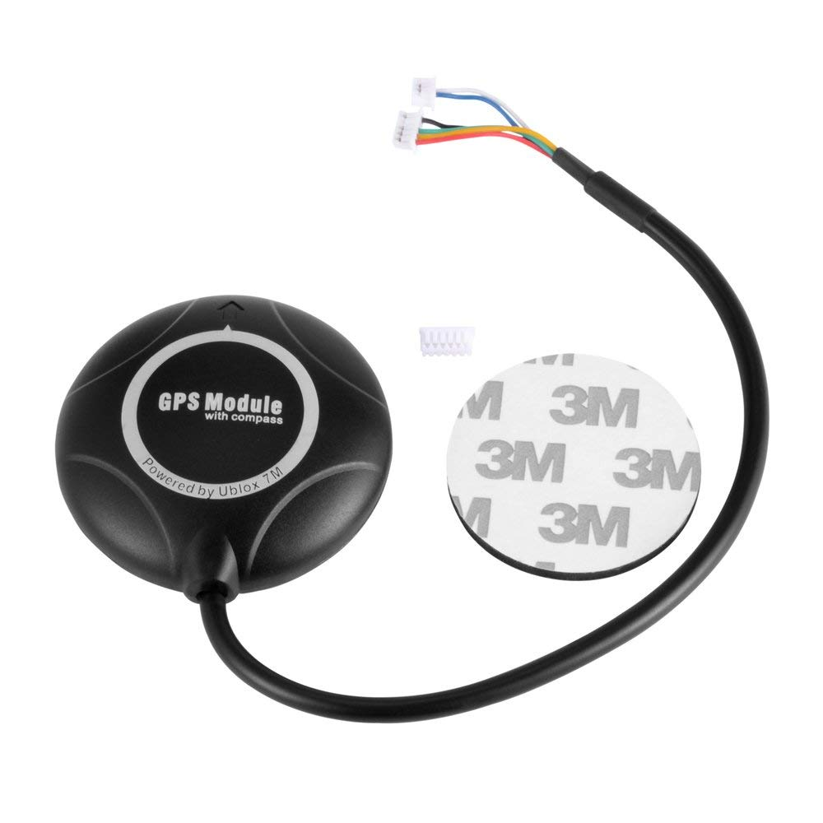

Ublox Neo 7M GPS module that includes an **HMC5883L digital compass.**  The new **Ublox NEO 7 series** is a high sensitivity, low power GPS module that has 56 channels and outputs precise position updates at 10Hz.  This GPS module also comes with a molded plastic case which keeps the module protected against the elements making it ideal for use on your aircraft or quadcopter.

This Ublox Neo 7M GPS module uses an active circuitry ceramic patch antenna to provide excellent GPS signal which outperforms the older Ublox Neo 6 series modules.   This Ublox Neo 7 module also includes a rechargeable backup battery to allow for HOT starts and also includes an I²C EEPROM to store the configuration settings.  Out of the box this GPS module is configured to run at 38400 Baud and is configured to run with **APM/Pixhawk** systems.  This GPS module includes two cables, a 6pin connector for the GPS module and a 4 pin connector for the i2c compass.

#### ****Features :****

1. Locate performance
2. These are Pre-configured, Flashed with the correct settings, and tested. To make them Plug and Play.
3. Super Bright LED
4. Backplane with Standard Mk style mounting holes 45mm X 45mm
5. 38400 bps (Default) Changed to 115200bps!
6. Output GGA, GSA and RMC frames
7. 1Hz (Default) Changed to 5Hz!
8. Permanent Configuration Retention
9. compass on board
10. 6 pin connector for EZ connect to MEGA BLACK
11. 4 pin connector for only GPS use
12. 4 pin connector for compass only use
13. Can use both 4 pin at once.

**Lipo Battery 2200mAh / 11.1V**

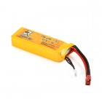

**Lipo Battery 2200mAh / 11.1V** has three cells and outputs 11.1V storing 2200mAh of charge.This is a good Li-po battery for projects like small robotics and radio-controlled projects. It has high discharge rates and big capacity and can be used in RC airplane, RC helicopter, RC car, RC truck, RC boat, drone applications. This high power output battery has very special internal structure, which requires dedicated balance charger to charge. Li-Poly Battery Charger is a suitable mate. iMAX-B6AC Battery Charger can be used to recharge this module.

**Specifications of Lipo Battery 2200mAh / 11.1V**

* Material: Li-polymer
* Battery voltage: 11.1 V
* Nominal capacity: 2200mAh
* Max. Charge current: 2.2A
* Discharge: 25C
* Wire length: 50 ± 5mm
* Cell: 3S

### Robocraze Flysky CT6B Remote 6 Channel Transmitter and Receiver for Quadcoopter RC-A-004

### 

This transmitter requires a PC to modify any of the channel variables, including mixing and servo reversing.

This is FS-CT6B 6ch 2.4GHz transmitter & receiver It has 0.8W transmitter with range up to 1km line of sight. Specifications: Channels: 6. Frequency: 2.4GHz.

##### Features:

* Channels: 6 Channels
* Model Type: Heli, Airplane, Glid
* RF Power: Less than 20db
* Modulation: GFSK
* Code Type: 2.4Ghz No Interference